Check if the server is ad joined  
  
open cmd run command

>>dsregcmd /status  
  
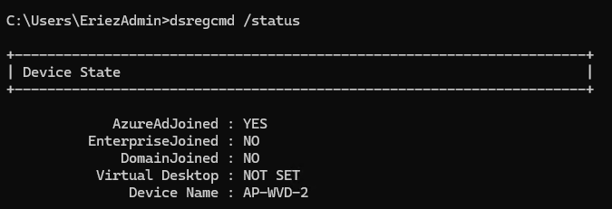

Or can check from setting  
  
>>setting -> account -> work or school

Check it’s joined to which domain

From cmd run command

>>systeminfo | findstr /B /C:"Domain"

Remove the server from azure ad domain

Go to setting, choose account and then school or work find the ad joined and disconnect.

Disconnect time provide alternative account to login after disconnecting that domain, because that organization account will not work. Need admin account to login.

Pc will be restarted after disconnection.

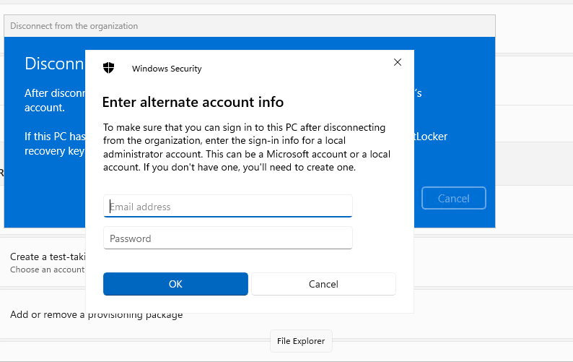

Add the server to new domain

Go to run option “win+r” and run

>>sysdm.cpl

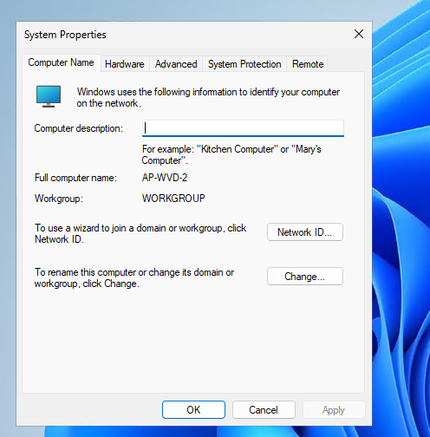

In computer name tap (on top) click on change option

Under **Member of**, select **Workgroup** to disconnect from the domain. After leaving the domain, you can then choose **Domain** to join a new one.

Provide the domain name to join to new domain.

Run cmd to verify domain join

>> systeminfo | findstr /B /C:"Domain"

Or if want to do from PowerShell cmd  
  
• To remove the server from the domain, run the following command:

powershell

Copy code

Remove-Computer -UnjoinDomaincredential Domain\Administrator -PassThru -Verbose -Restart

Replace Domain\Administrator with the credentials of a domain account that has permission to unjoin the server from the domain.

• After the server restarts, you can join it to a new domain by logging in with a local account and using the Add-Computer command:

powershell

Copy code

Add-Computer -DomainName "NewDomainName" -Credential NewDomain\Administrator -Restart

Replace NewDomainName and NewDomain\Administrator with the appropriate domain name and credentials.